**Introduction**

* Wound detection, classification, and segmentation are critical components in modern healthcare, aiming to improve the accuracy and efficiency of wound management. These processes involve the application of advanced technologies and algorithms to identify, categorize, and delineate wounds from medical images.
* **Wound Detection** is the initial step where the system identifies the presence of a wound within an image. This process is essential for automating wound care and monitoring, particularly in environments where timely intervention is crucial. Accurate detection helps in prioritizing cases and facilitating early treatment, which can significantly impact patient outcomes.
* **Wound Classification** follows detection, where the system determines the type of wound. This step involves categorizing wounds into various classes, such as diabetic wounds, pressure wounds, surgical wounds, or other wounds based on their appearance and characteristics. Classification is vital for developing appropriate treatment plans and ensuring that patients receive the most effective care tailored to their specific condition.
* **Wound Segmentation** involves the precise delineation of the wound area from the surrounding tissues in an image. This process generates detailed maps of the wound, providing critical information about its size, shape, and boundaries. Accurate segmentation is essential for monitoring wound progression, evaluating treatment efficacy, and facilitating research into new wound care technologies.

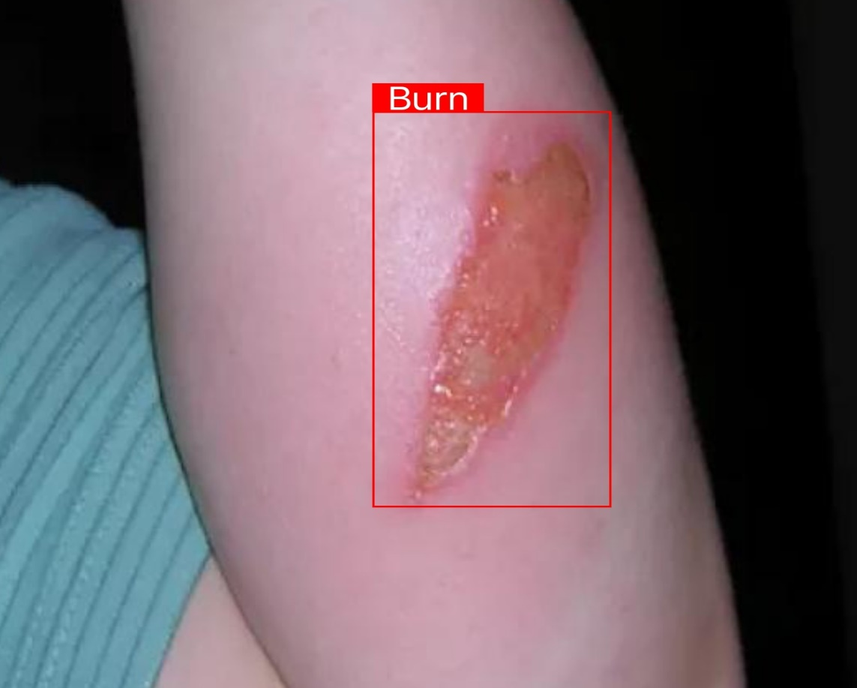

Figure-1: Wound Detection And Classification

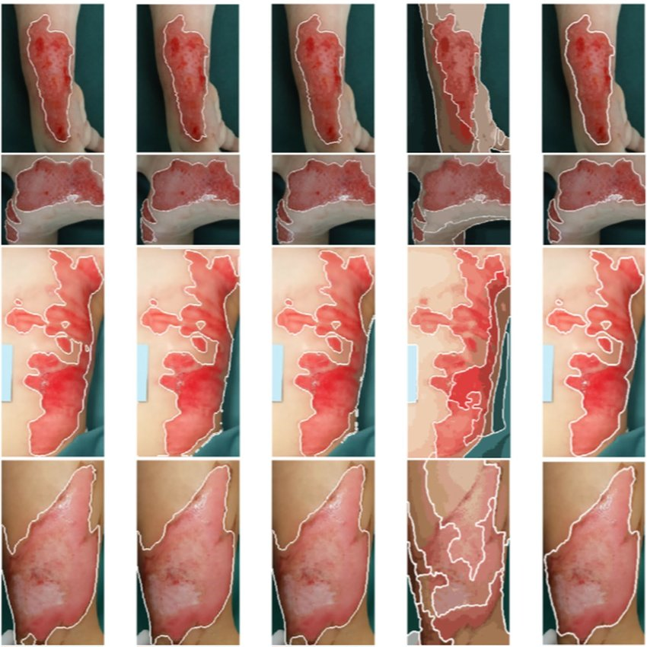

Figure-2: Wound Segmentation

Source Fig1: https://www.kaggle.com/datasets/ibrahimfateen/wound-classification

Source Fig2: https://www.researchgate.net/figure/Segmentation-results-for-six-different-burn-wound-images-the-1-st-column-shows-the_fig7_331454489

**Problem Statement**

* In a hospital there are so many patients waiting to meet the doctor. Patients who suffer from extreme wounds may need to wait for long time in order to meet the doctor.
* By using a system of wound classification we can prioritize a patient.
* Also, when a patient comes back after a specified period of time for a follow up, the doctor may not remember the last condition of wound.
* Here accurate segmentation is essential for monitoring wound progression and evaluating treatment efficacy.
* Often patients feel ashamed to talk about the actual cause of wound or patients themselves are not sure about the actual cause of wound.
* In this case a model trained with hundreds of images can accurately predict the type of wound which will be helpful in the effective treatment of the wound.

**Literature Review**

|  |  |  |  |  |
| --- | --- | --- | --- | --- |
| **Author & Year** | **Title** | **Technique & Method Used** | **Dataset** | **Publication** |
| Domagoj Marijanovic et al. (21/01/2022) | Wound Detection by Simple Feedforward Neural Network | Techniques typically involve preprocessing images to enhance features relevant to wound detection, such as using filters or segmentation methods. The neural network then learns to classify or detect wounds by analyzing the pixel patterns in these preprocessed images. | Foot Ulcer Segmentation Challenge. Available online: https://fusc.grand-challenge.org/ (accessed on 8 September 2021) | MDPI, Basel, Switzerland. |
| Mohammad Jafari et al.  (21/03/2022) | Automatic wound detection and size  estimation using deep learning algorithms | Convolutional Neural Networks (CNNs) are commonly used to extract features from wound images and detect wounds by identifying patterns and anomalies. Advanced architectures, such as U-Net or YOLOv7, are employed for segmentation tasks, allowing the model to delineate wound boundaries accurately. | The original dataset consists of approximately 256 images of wound inflicted lab mice (see “Wounding surgery and daily imaging” for details). | Public Library of Science(PLOS),  San Francisco, California, United States |
| Chien-Yao Wang et al.  (06/07/2022) | YOLOv7: Trainable bag-of-freebies sets new state-of-the-art for real-time object  detectors | YOLOv7 performs classification and segmentation by leveraging a unified architecture designed for both tasks. For classification, it uses a backbone network to extract features from images, followed by a head that assigns class labels to detected objects. For segmentation, YOLOv7 integrates segmentation heads that refine object boundaries and provide pixel-level masks, allowing precise delineation of objects within images. | <https://www.kaggle.com/>  datasets/ibrahimfateen/  wound-classification | arXiv, New York, NY 10044 |

**Research Gap**

**Workflow**

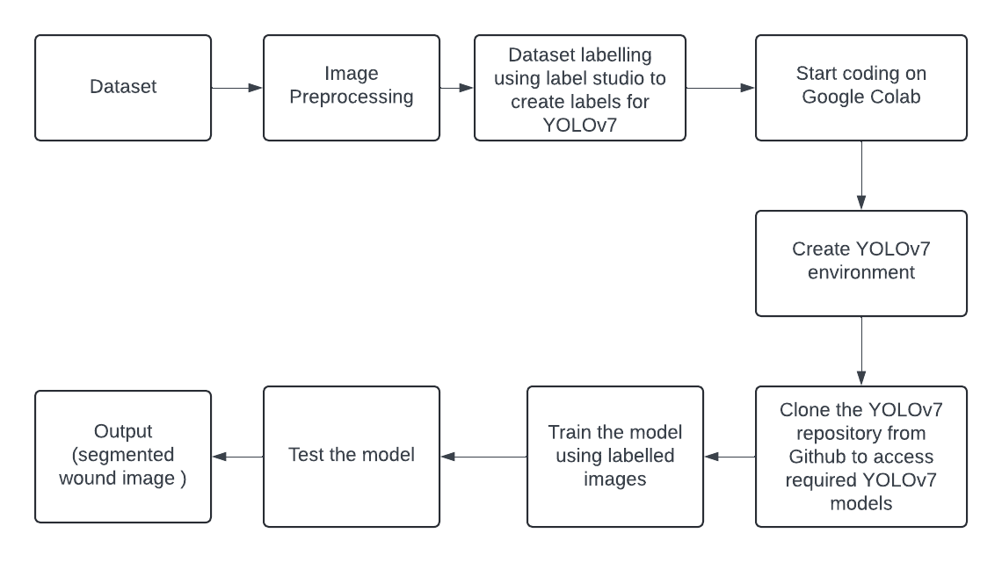

**Proposed Algorithm**

The implementation phase follows in three stages, each with distinct and discrete purpose to ensure optimal and well-learned categorization of Wound Detection, viz. **Pre-processing** of the input images to enhance model accuracy, **Classification** of wounds into different categories by detecting them and finally **Segmentation** of the wound area.

**Pre-processing**

Pre-processing images is a crucial step in preparing data for training and inference using YOLOv7 [1] . This process involves several key tasks aimed at optimizing the quality and consistency of the input data, which in turn enhances the model's performance. Initially, images are resized to match the input dimensions expected by YOLOv7 [1], typically 640x640 pixels. Resizing helps maintain a uniform input size, ensuring the model can process data efficiently. Alongside resizing, normalization is applied to scale pixel values to a standardized range, typically between 0 and 1, which aids in stabilizing and speeding up the training process. Data augmentation techniques such as random cropping, flipping, rotation, and colour adjustments are also employed to increase the diversity of the training set, making the model more robust to variations in real-world data. Additionally, annotations for object bounding boxes are adjusted to align with the transformed images. Proper pre-processing ensures that the model is trained on high-quality, well-augmented data, leading to better detection and segmentation accuracy during deployment.

**Classification**

YOLOv7 [1] , a state-of-the-art deep learning model, excels in image classification by efficiently identifying and categorizing objects within an image. As an evolution of the YOLO (You Only Look Once) series, YOLOv7 [1] integrates enhanced architecture and optimization techniques to achieve remarkable accuracy and speed in image analysis. The model processes an image by dividing it into a grid, predicting bounding boxes, and assigning confidence scores and class probabilities to each box. This enables YOLOv7[1] to not only detect the presence of objects but also classify them with high precision, even in complex and crowded scenes. Its ability to perform real-time classification makes it highly valuable for applications that require quick and accurate image processing, such as medical imaging, autonomous driving, and surveillance. YOLOv7's efficiency in handling diverse datasets and its robust generalization capabilities further solidify its position as a leading tool for image classification tasks.

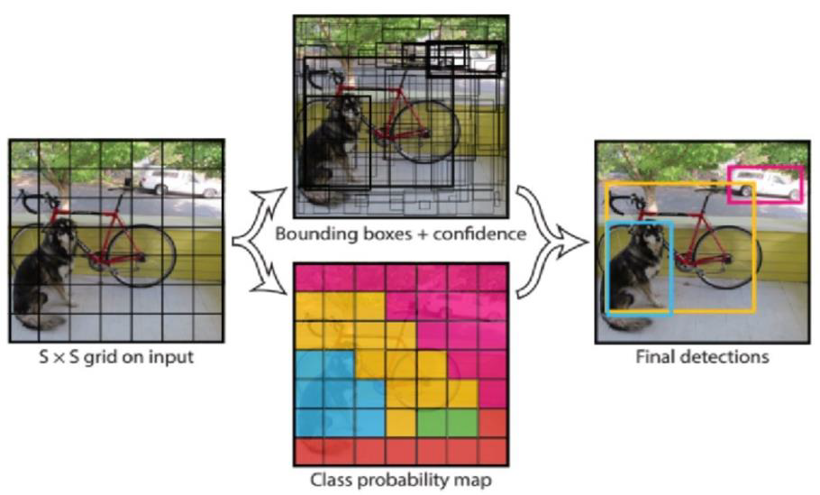

**Fig 3:** Working of YOLO algorithm for classification

**Segmentation**

Semantic segmentation of images is a critical task in computer vision, where the goal is to classify each pixel in an image into a specific category, resulting in a detailed and meaningful representation of the scene. YOLOv7 [1], a cutting-edge object detection model, extends its capabilities to semantic segmentation by leveraging its efficient architecture and real-time processing speed. Unlike traditional object detection, which identifies and classifies bounding boxes, semantic segmentation with YOLOv7 [1] goes a step further by assigning a class label to every pixel in the image. This pixel-level precision is particularly useful in applications requiring detailed understanding of the visual content, such as medical imaging, autonomous driving, and environmental monitoring. YOLOv7's advanced feature extraction and processing capabilities make it well-suited for semantic segmentation tasks, enabling accurate and fast analysis even in complex and cluttered scenes.

We have chosen YOLO over U-Net [2] or any other algorithm because YOLO (You Only Look Once) is designed for speed and can perform object detection and segmentation in a single pass through the network, making it highly suitable for applications requiring fast decision-making, such as in autonomous vehicles or live video analysis. While U-Net [2] excels at producing highly detailed segmentation maps, it can be computationally intensive and slower, which may not be ideal for time-sensitive tasks.

**References**

[1] Wang, C.Y., Bochkovskiy, A., Liao, H.Y.M.: YOLOv7: Trainable bag of-freebies sets new state-of-the-art for real-time object detectors. In: Proceedings of the IEEE/CVF Conference on Computer Vision and 18 ZHAO ET AL. Pattern Recognition, pp. 7464–7475. IEEE, Vancouver, Canada (2023). <https://doi.org/10.48550/arXiv.2207.02696>

[2] Marijanović, D., Nyarko, E.K., & Filko, D. (2022). Wound Detection by Simple Feedforward Neural Network. Electronics.

[3] Carrión H, Jafari M, Bagood MD, Yang HY, Isseroff RR, Gomez M. Automatic wound detection and size estimation using deep learning algorithms. PLoS Comput Biol. 2022 Mar 11;18(3):e1009852. doi: 10.1371/journal.pcbi.1009852. PMID: 35275923; PMCID: PMC8942216.